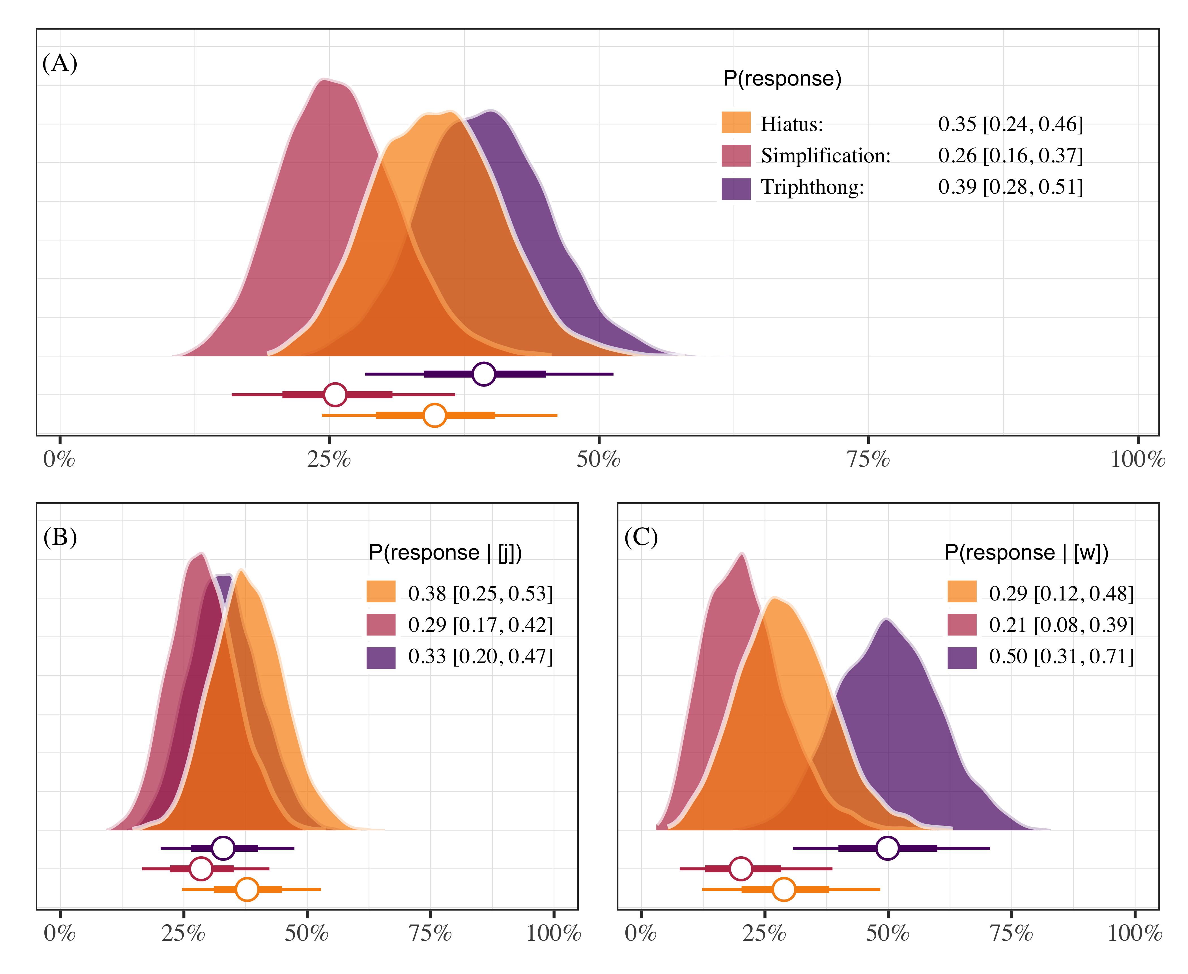

Figure 4.1: Posterior probabilities of responding “hiatus”, “triphthong”, or “simplification”. Each panel plots the posterior medians ±66% and 95% credible intervals. Panel A shows overall responses, and panels B and C show responses as a function of glide type.